**Introduction to Shell Script**

1. Create a script named “myscript” in current directory to do the following.

a) display “hello user”

b) list files in current directory

c) name of logged in user

d) date

a. Myscript script is created using “vi myscript.sh”

>>Echo “hello user”

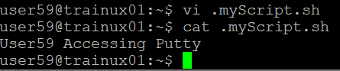

Cat file_name is used to display the contents of the file.

b. To list the files in current directory “ls” command is used.

c. For the name of logged in user “whoami” command is used.

d. To get date, “date” command is used



2. Add execute permission and Run the script from

a) current directory

To add execute permission on the file “chmod +x myscript.sh” command is used.

* To execute in the current directory “./myscript.sh” is used.

3. Create a subdirectory named “test”

To create a subdirectory names test “mkdir test” is used.

1. Change to “test” directory. Run the script “myscript” [Hint: You will have to update PATH to include the directory containg script to run script from any location].

To change to test directory and execute the myscript the commands used are:

>>cd test

>>export PATH=$PATH:$ (pwd)/..

>>myscript.sh

